TENBURY HIGH ORMISTON ACADEMY

Special Educational Needs (SEN) Information Report
Last reviewed on: | 05.09.2025
Next review due: | No later than 01.09.2026


Introduction
The aim of this information report is to explain how we implement our SEND policy.

We hope parents of current and prospective children find the following information helpful and we encourage you to contact the academy for more information.

If you want to know more about our arrangements for SEND, please read our SEND policy. You can find it on our website: https://tenburyhighormistonacademy.co.uk/admin/wp-content/uploads/sites/55/2025/09/OAT-SEND-Policy-updated-for-THOA-September-2025-2.docx

At Ormiston Academies Trust, we are committed to delivering an equitable, high-quality education that recognises and nurtures the unique strengths and potential of every child.

Tenbury High is a school where culture and ethos are at the heart of everything we do. We are a caring and inclusive community, where every child is known, valued and supported as an individual. Our motto, “high achievement, outstanding care,” is not just a phrase but a lived reality, shaping the way we teach, support, and nurture every pupil. Staff are committed to providing personalised approaches to learning, ensuring that all children are encouraged to flourish academically, socially, and emotionally. We are proud to foster a learning environment where pupils feel safe to take risks, build resilience, and develop independence. Alongside strong academic achievement, we prioritise kindness, respect, and curiosity, helping our pupils grow into thoughtful young people who are prepared for the next stage of life. Most importantly, Tenbury High is a place where pupils are happy, engaged, and inspired to embrace lifelong learning.

If you would like to have this report read aloud as an audio, you can use a free reader at: https://www.naturalreaders.com/. If you have any difficulties accessing this report, please contact the academy and we will support you.

If there are any terms we’ve used in this report that you’re unsure of, you can look them up in the glossary at the end of the report.


Name and contact details of key staff

SENCO  Mrs Marie Bradbury  mbradbury@tenburyhigh.co.uk |  | Assistant SENCO  Mrs G Parker  gparker@tenburyhigh.co.uk |  | Assistant SENCO  Mrs J Palmer  jpowell@tenburyhigh.co.uk
Teaching Assistant  Mrs Z Bakewell |  | Teaching Assistant  Miss G Booton |  | Teaching Assistant  Ms A Clarke
Teaching Assistant  Miss H Genner |  | Teaching Assistant  Mrs N Jackson |  | Teaching Assistant  Mrs C Wright
Head of Year 7  Mr J Hawkins  jhawkins@tenburyhigh.co.uk | Head of Years 8 and 9  Mr R Morris  rmorris@tenburyhigh.co.uk |  | Head of Years 10 and 11  Mrs G Prouse  gprouse@tenburyhigh.co.uk


The kinds of SEND we provide for in our academy
At our academy, we provide support for children with a range of needs, including the following:

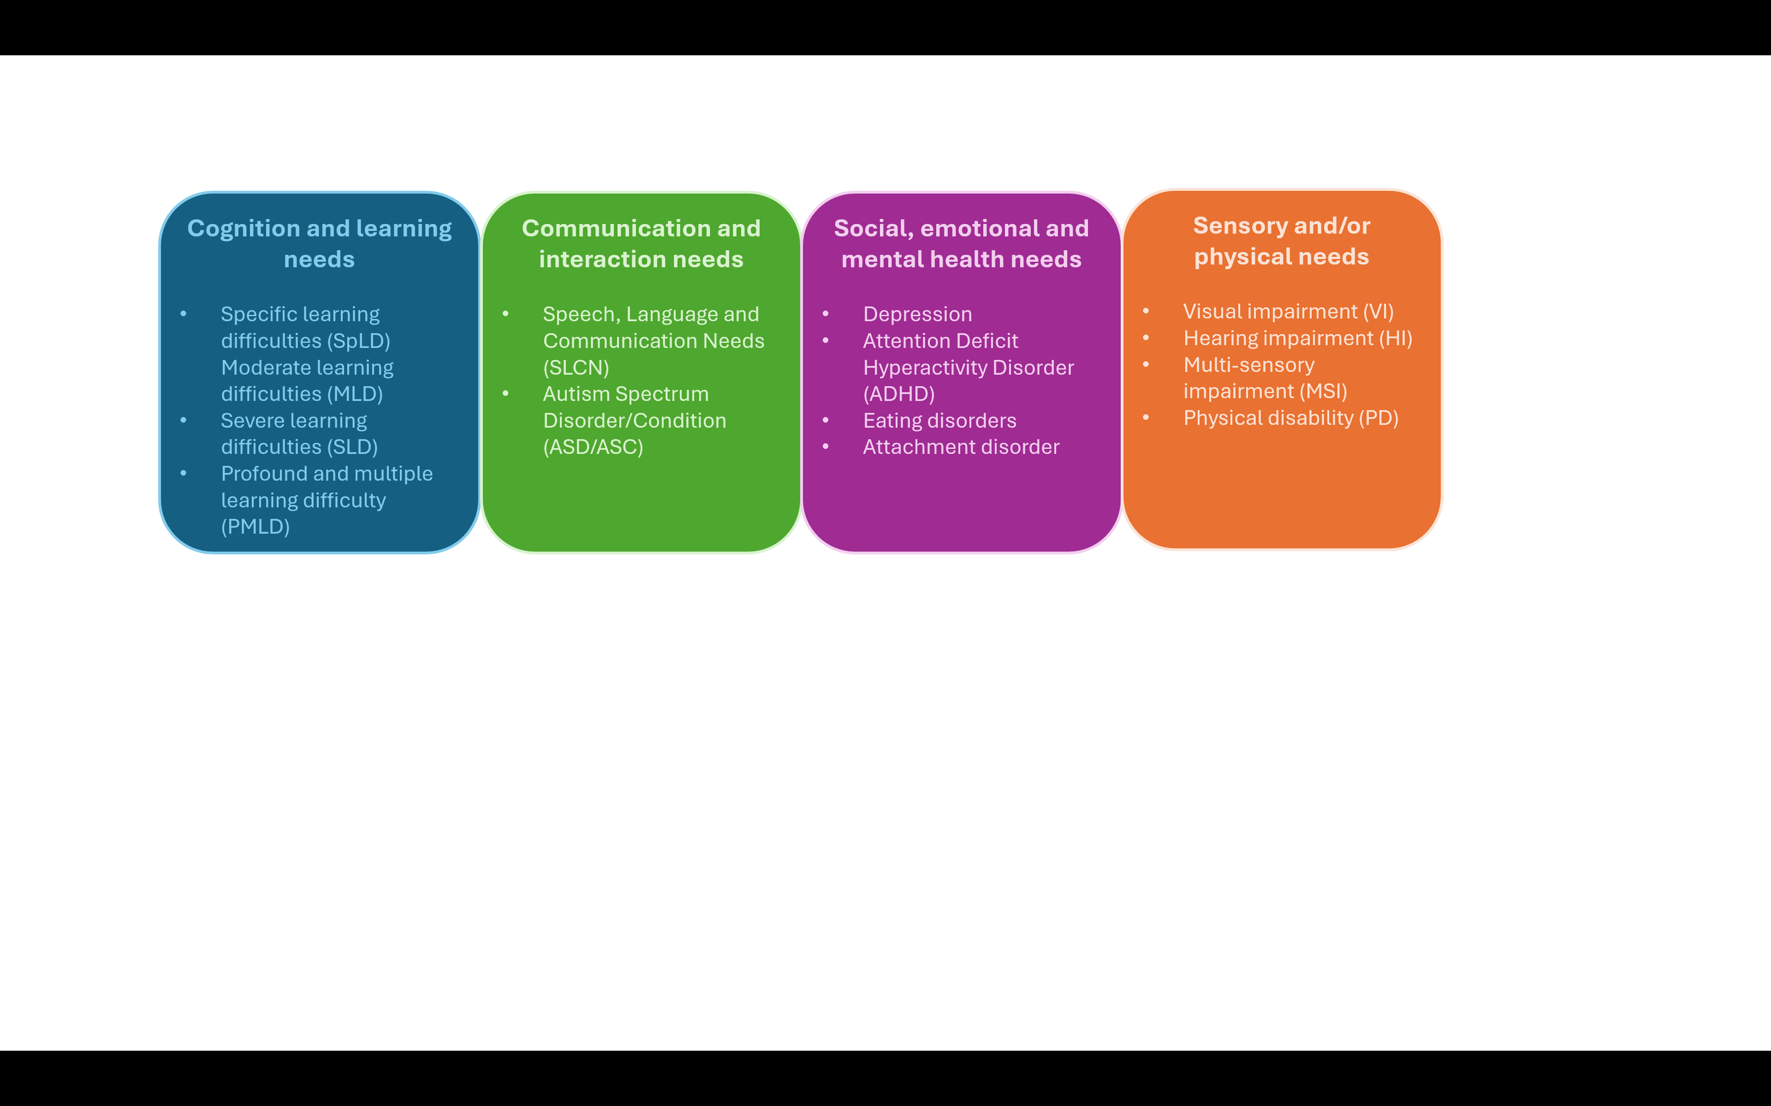


Here is our SEND data, correct at time of publishing
 | Number | % of cohort
No SEND | 108 | 23.7%
SEN Support (K) | 86 | 18.9%
EHCP (E) | 22 | 4.8%

 | EHCP  (number / %) | SEN Support (K)  (number / %) | Total  (number / %)
Cognition and learning | 10  (45% of all students with EHCPs) | 45  (52.3% of all students at SEN Support) | 55  (50.9% of all students with SEN)
Communication and interaction | 6  (27% of all students with EHCPs) | 13  (15.1% of all students at SEN Support) | 19  (17.5% of students with SEN)
Social, emotional and mental health | 6  (27% of all students with EHCPs) | 23  (26.7% of all students at SEN Support) | 29  (26.8% of all students with SEN)
Sensory and/or physical | 0 | 7  (8.1% of all students at SEN Support) | 7  (6.4% of all students with SEN)


How we identify SEN and assess needs
Our teachers are trained to identify any barriers that may hinder a child making progress. We aim to identify support as early as possible to overcome these. If this doesn’t help, we will work with the child and their parents to consider the next steps. Our SENCO will support this process.

How we identify and support children with SEND:

Sharing a Concern
- If a teacher has concerns about a child, they will try some strategies in class first to see if this helps.
- Parents and carers can raise concerns directly with the SENCO (via Edulink, email, phone, or through the school office).
- Pupils can also share their worries with a trusted adult in school, who will pass this on to the SENCO.

First Steps in School
- Teachers check whether a child already has a known need and use strategies from their pupil passport if one is in place.
- If no SEN is identified, teachers put in place additional classroom support and keep a close eye on how the child is doing.

Gathering Information
- If concerns remain, the SEND team will look more closely at the child’s learning. This may include observing in lessons, looking at their work, talking to them, and gathering views from all of their teachers.
- We also use school information such as attendance, behaviour, and progress data, along with assessments like reading and cognitive tests (NGRT, CAT4, PASS).

What Happens Next?
- The SENCO reviews all the information and decides what the next steps should be:
  - If there is clear evidence of a special educational need, parents are invited to a meeting to discuss placing the child on the SEND register and co-producing a pupil passport.
  - If there may be a special educational need, further assessments (such as dyslexia or memory screeners) may be carried out, and referrals to outside specialists may be made with parental consent.
  - If there isn’t enough evidence at this stage, the child will continue to be monitored and supported, with regular reviews.

Assessments and Tools We Use
- We use a range of assessments including reading tests (NGRT), attitude surveys (PASS), cognitive tests (CAT4), and school data on attendance, behaviour, and progress.
- Additional screeners (e.g., dyslexia, dyscalculia, working memory) may also be used when needed.

Working with Specialists
- Sometimes we ask for advice or support from external professionals such as Speech and Language Therapists, specialist teachers from the Learning Support Team, Occupational Therapists, or CAMHS. We will always ask for parental consent before making any referral.

Monitoring and Review
- We regularly review how children are getting on through classroom observations, book looks, data, and feedback from teachers, parents, and pupils.
- Pupil passports are written with parents and children and updated regularly.
- We check that any extra help or interventions are making a positive difference and adjust them if needed.

Your child may be identified as having a special educational need. The first stage of additional or different support is called SEN Support. If, under SEN Support, your child has still not made expected progress, we and/or you may consider requesting an Education, Health, and Care (EHC) needs assessment. This is coordinated by the local authority. Some children will have an Education, Health and Care Plan (EHCP) – this is a legally-binding document that sets out a child’s needs and the provision that will be put in place to meet their needs.


How we work with children and their families
We always take into account the views of children and their families, when planning support for a child in the academy.

We ask children about the help they get by regularly undertaking pupil voice activities – sometimes these are on a 1-1 basis, sometimes they are in small groups.

It is important that parents are able to share concerns and to discuss next steps. Parents of children with SEN are invited to a 1-1 meeting with SENCO before their child starts at Tenbury High. The SENCO attends the ‘Year 7 Welcome Evening’ and other events for groups of parents throughout the year and is always available afterwards for informal conversations if parents have any concerns. The SENCO is also present at parent/teacher consultation evenings and parents of children with SEN are invited to attend an appointment. The SENCO can be contacted via the school office or via email.


How we support children in transitions and in preparing for adulthood
Before a child joins our academy, we gather information in the following ways:
- We gather information by visiting their primary schools. If possible, we arrange to meet the children in their primary school as it is a familiar environment for them.
- The SENCO attends the ‘Welcome to Year 7’ evening.
- The SENCO invites parents of children with EHCPs to an informal meeting to explain about the transition process.
- For children with EHCPs or high level needs we invite them to attend additional transition activities, before the main, whole cohort welcome day.
- The SENCO invites all parents of children with SEN to an informal 1-1 meeting before they start at Tenbury High Ormiston Academy.

To help children be prepared for moving from Year 6 into Year 7 we:
- Work closely with parents to create a pupil passport that is shared with all teachers and teaching assistants. The pupil passport includes a ‘pupil voice’ section, identified needs and barriers, strengths, in-class strategies to support and interventions.
To help students be prepared for moving from Year 9 to Year 10 we:
- Hold an ‘Options Evening’ and invite parents/carers and pupils to attend. At this meeting members of the senior leadership team, subject specialist teachers and the SENCO are available to meet informally to discuss the suitability of different option choices.
- Have 1-1 options meetings with each pupil to discuss their preferences and the expectations of each course. This is to make sure they are making decisions about their option choices that are well matched to their strengths and interests.
- Hold ‘Stepping into Key Stage 4’ meetings. During these meetings we meet each child on the SEN register on a 1-1 basis to explain some of the expectations that will be had of them in Year 10 and 11. We then meet with their parents/carers to discuss any changes that need to be made to provision to ensure their child’s success in Key Stage 4.

If a child is moving on to a new school, we ensure that any information is passed on in a timely manner.

We work with the child to help them achieve their ambitions, which can include goals in higher education, employment, independent living and participation in society. We provide all of our children with appropriate advice on paths into work or further education.

We support children with SEND to prepare for adulthood by:
  - Holding careers events from Year 7 upwards e.g., the Careers Detective events in Years 7 and 8, inviting visiting speakers to assemblies, including speakers from apprenticeship providers and universities
  - Supporting them to set up suitable work experience in Year 10
  - Providing additional and/or early careers advice
  - Providing opportunities to visit colleges such as the ‘Three Colleges Open Day’ and signposting parents to open events at other appropriate settings such as Hoople and HOW (Heart of Worcester College).
  - Taking part in ‘Life Beyond School’ events specifically designed for students with SEND organised by local authorities
  - Through our Personal Development curriculum, we educate our children about the full range of opportunities that are available once they leave school
  - Providing them with a mock interview with someone from a local business or educational setting. This is followed up with feedback about how they came across in the interview.
  - Arranging for college interviews to take place in school which is a familiar setting.
  - Inviting SEND/Inclusion Managers from further education settings/post 16 institutions to review meetings in Year 10 and 11.


How the curriculum and learning environment is adapted to meet the needs of all children and how we make sure teaching is effective for all children
We believe that an inclusive education begins with ambitious, accessible curricula and expert teaching. Leaders carefully design the curriculum to be flexible but rigorous, ensuring that all children can access challenging content.

Information on our curriculum can be found here: Tenbury High - Curriculum Overview

We aim to ensure every child has access to high quality teaching as we know this has the greatest impact on outcomes, especially for children with additional needs. CPD supports staff to design lessons with children with the highest needs in mind. We use a range of adaptive strategies that remove barriers to learning. In addition, children receive quality support and interventions that align with best practice and utilise a graduated approach.

Support might include:
- Pre-teaching vocabulary or concepts
- Small group interventions, such as Lexonik, Fresh Start
- Multi-sensory resources
- Adult support
- Classroom strategies such as learning scaffolds, additional time for processing, additional checking for understanding
- Access to digital devices such as laptops and reading pens
- Specialist equipment, such as writing slopes, pencil grips
- Programmes set by external specialists from the Learning Support Team


Arrangements for assessing and reviewing progress towards outcomes
We follow the “graduated approach” to meeting children’s needs. This is a four part cycle of Assess, Plan, Do, Review.

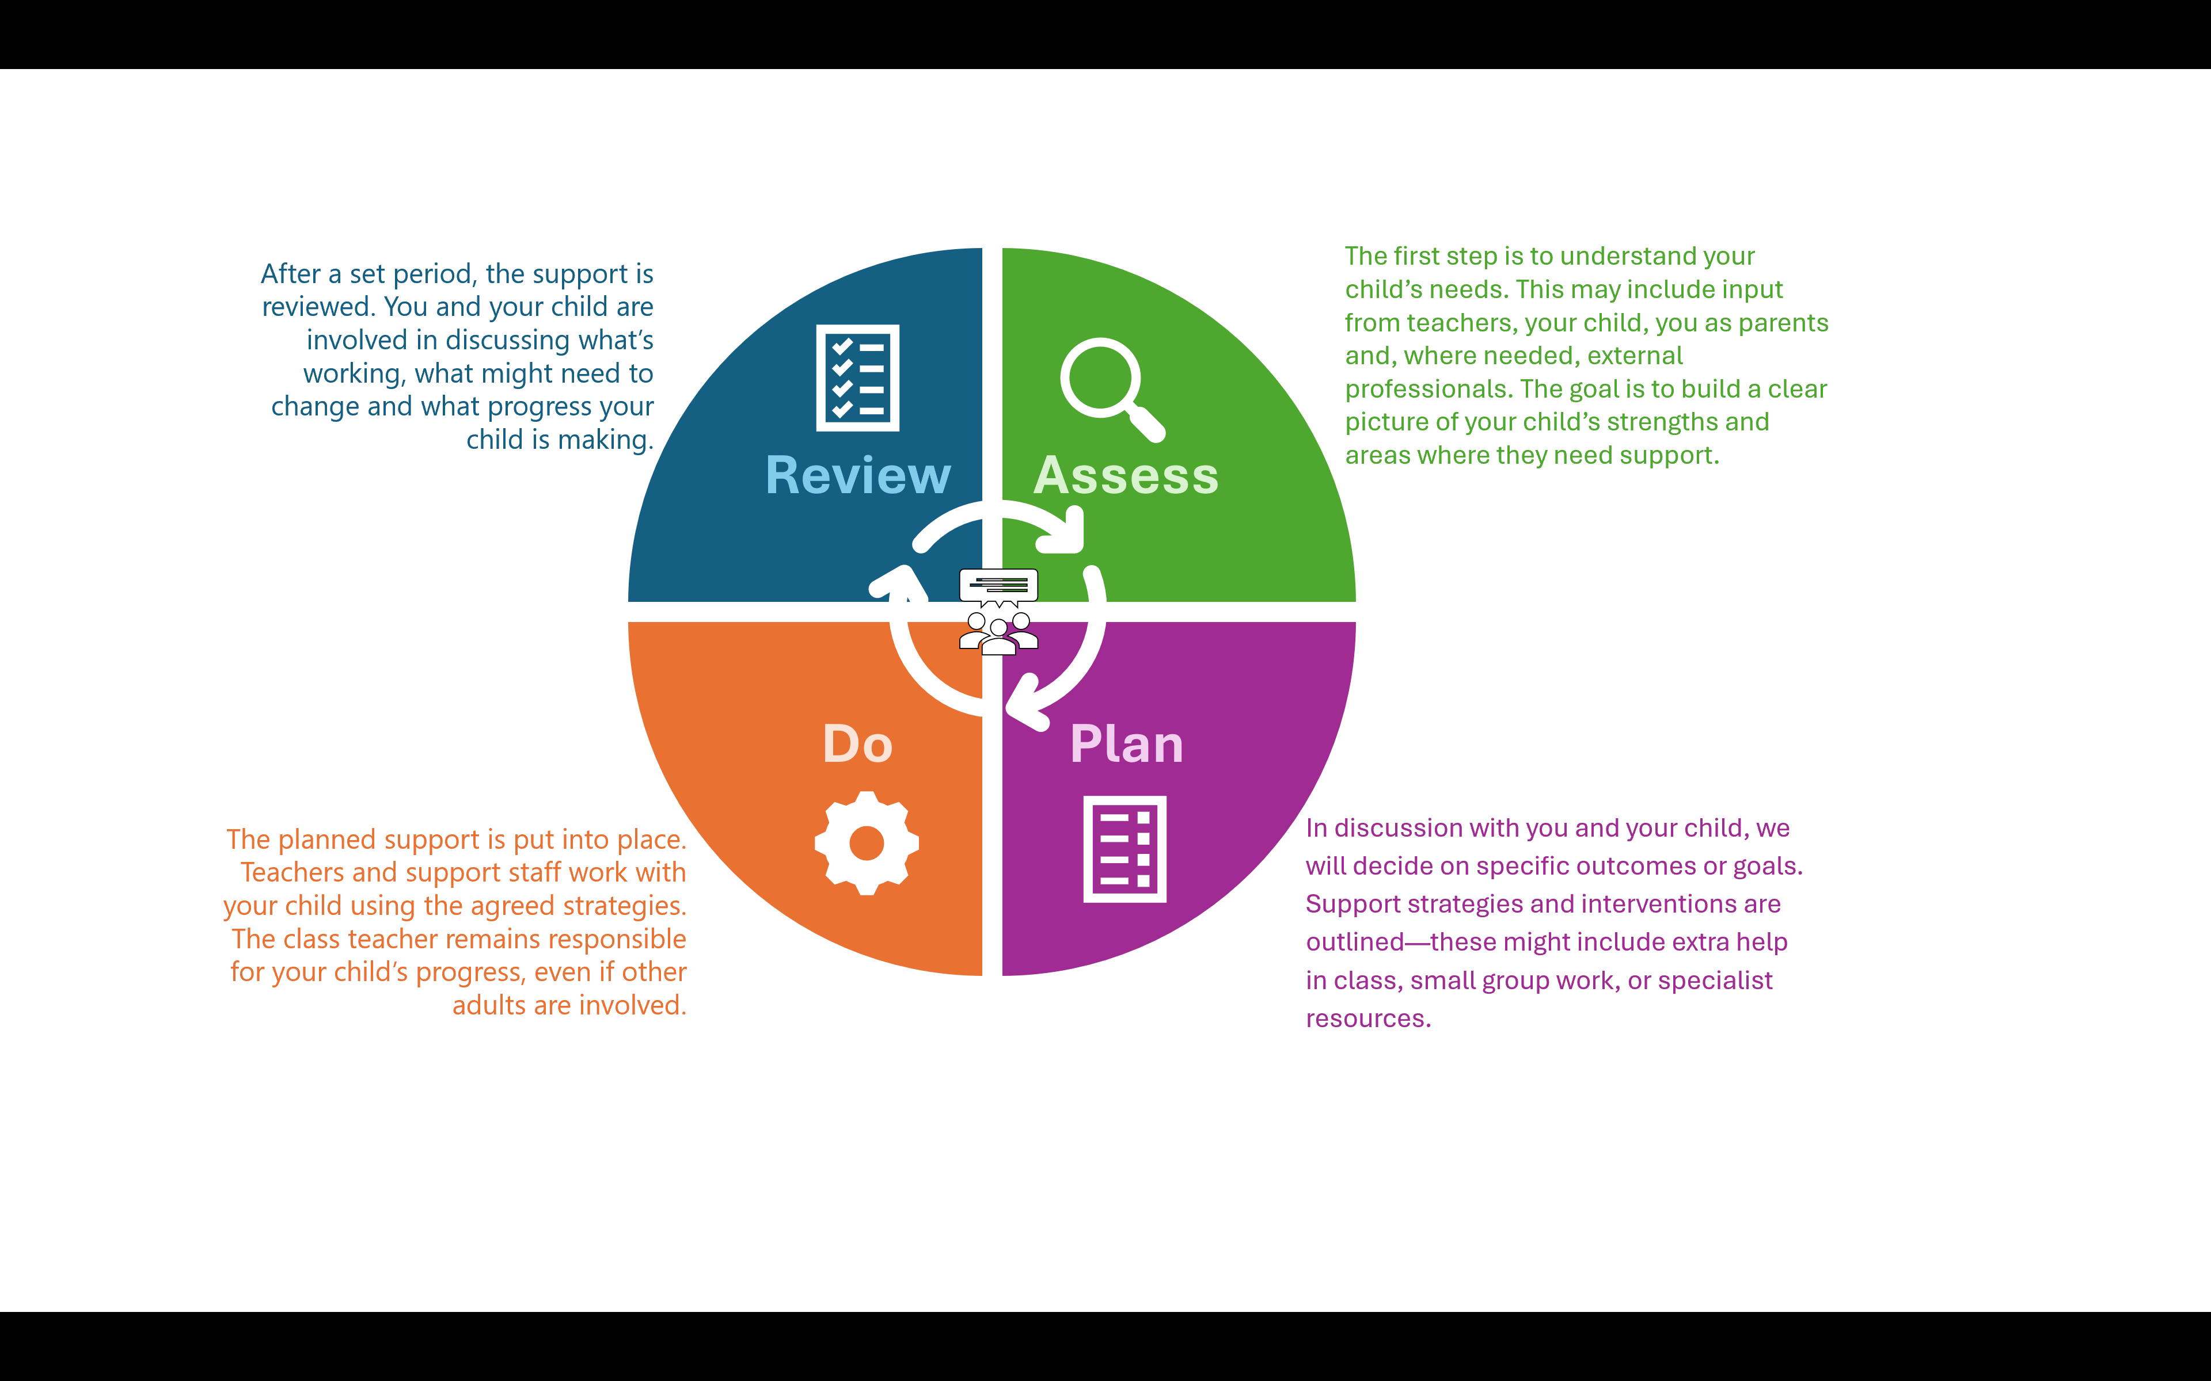
At Tenbury High Ormiston Academy we measure and review pupil’s progress in the following ways:
- Termly progress reports for each faculty and for key groups of pupils e.g., those with SEND, children who are looked after or post looked after.
- During EHCP Annual Reviews we review pupil’s progress towards the outcomes specified in their EHCP.
- Regularly analysing data about attainment, achievement/progress, behaviour and attendance.
- Regular pupil progress meetings.


How we support emotional and social needs
We provide a range of strategies, support and interventions to support children’s emotional and social needs.
- Zero tolerance for bullying – bullying of any kind, whether in school, online, or outside the school gates, is taken seriously and dealt with promptly.
- Multiple ways to report – pupils can report concerns directly to staff, anonymously via the Edulink app, or by speaking to a trusted adult.
- Support for pupils who experience bullying – includes a named staff member to check in regularly, peer mentoring, “Circle of Friends” groups, access to the pastoral team, counsellors, and restorative approaches to rebuild confidence.
- Support for pupils involved in bullying behaviour – includes discussions about what happened, restorative meetings (if agreed by both parties), friendship skills groups, and referrals to outside agencies if needed.
- Curriculum education – through the Personal Development and Computer Science curriculum, assemblies, and themed weeks such as Anti-Bullying Week pupils are explicitly taught about respectful relationships, online safety, resilience, and empathy.
- Extra support for vulnerable groups – including pupils with SEND, young carers, children who are looked-after, and those who may find it harder to express concerns. Strategies include Teaching Assistant support, tutor check-ins, buddy systems, peer-to-peer support, and mediation.
- Regular pupil voice – half-termly school council meetings, pupil voice activities and pupil surveys always include questions on bullying to ensure that student views are heard and acted upon.

As well as this additional support, all children have access to a well-planned Personal, Social, Health and Economic (PSHE) curriculum. Here is a link to further information about our Personal Development curriculum: Tenbury High - Personal Development


How we make sure that all children can access a wide range of activities
All of our extra-curricular activities and academy visits are available to all of our children. All children are encouraged to go on our trips, including our residential ones. We plan a wide range of exciting opportunities such as e.g., extra-curricular clubs, residential trips, curriculum drop down days, Sports Days and all children are encouraged to participate. No child is ever excluded from taking part in these activities because of their SEN or disability and we will make whatever reasonable adjustments are needed to make sure they can be included.

We ensure access by providing additional information sessions where small groups of pupils are given more detailed information about events, can ask any questions or talk about any worries they have to aid their confidence in participating. We make physical adaptations so that activities are accessible to all. We undertake risk assessments to eliminate or minimise any potential barriers to pupils taking part. This sometimes results in providing additional adult support.


What expertise have our staff got and what training have we had?
We ensure that all of our staff feel confident in meeting the range of needs of our children. Inclusion runs through all of our training so that staff see SEND as a whole academy responsibility.

Any specific training is built into whole academy approaches. As well as this we have staff trained in the following:
- Worcestershire Autism Mentoring (WAM) Project
- Assessing for the provision of exam access arrangements
- Mental Health First Aid
- Signalong and augmentative communication (a TOTAL approach to communication – visuals and gestures/signing alongside spoken words)
- Trauma Informed Schools (TIS)
- Understanding the Impact of Trauma on Young Children
- Tourette’s Syndrome
- Dyslexia Awareness


Who else do we work with?
Sometimes we need extra help to offer our children the support they need. Wherever necessary we will work with external support services to meet the needs of our children and to support their families. These include:
- Learning Support Team - Worcestershire
- Speech and Language Therapists – NHS and private specialists
- Educational Psychologists
- MentorLink
- Onside
- WEST (Worcestershire Emotional Support Team)
- YMCA
- CAMHS
- Stepping Stones
- BeeU
- Occupational Therapy
- Children’s Services for Worcestershire, Herefordshire and Shropshire
- Longlands Care Farm
- Aspire Academy
- Ranstad (tutoring)
- Bonterre
- OAT Mental Health lead
- Qualified Teacher of the Deaf
- Autism and Complex Communication Needs Team - Worcestershire


How we evaluate the effectiveness of our provision
We ensure that the provision we offer is effective by monitoring individual children’s progress (see above) but we also have a number of other mechanisms to evaluate whether what we offer is of high quality:

- Analysing data in a number of areas to monitor progress e.g. using WRAT5 assessments to evaluate the effectiveness of Lexonik interventions
- Frequent classroom visits by members of the school’s senior leadership and middle leadership team (heads of faculties and heads of year).
- Monitoring/health check visits from Ormiston Academy Trust (OAT) that focus on SEND provision

Our Governor for SEND supports the academy in ensuring we implement the SEND policy effectively.

Information on our accessibility plan
We have an accessibility plan which outlines our plans to increase the extent to which children with disabilities can participate in the curriculum; how we improve the physical environment to increase the extent to which children with disabilities can take advantage of the educational benefits, facilities or services provided or offered; and improve the way children with disabilities can access information that is easily accessible to children who are not disabled.

Our accessibility plan can be found here: THOA-Accessibility-Plan-Jan-2024.docx

We support children with disabilities by:
- Working closely with specialist services and health professionals (e.g. advisory teachers, NHS staff) to support children’s learning and wellbeing.
- Ensuring our school environment is accessible, for example with wheelchair access, improved lighting, acoustics, and colour schemes to support those with sensory or physical needs.
- Providing assistive technology and resources such as laptops, reading pens, and other ICT adaptations such as dictation software.
- Promoting a positive understanding of disability and neurodiversity across the school, so pupils learn to respect and value diversity (e.g., taking part in celebration weeks/months such as ‘Neurodiveristy Week’).
- Making information available in alternative formats (e.g. large print, electronic copies, or other formats on request).


How we make sure the admissions process is fair for children with SEND
At Tenbury High Ormiston Academy, we welcome applications from all children, including those with special educational needs (SEN) and disabilities. Our admissions process is designed to be open, fair and inclusive, and we make sure that no child is disadvantaged because of their needs.
Children with an Education, Health and Care Plan (EHCP)
- If a child has an EHCP which names our Academy, they will be offered a place.
- This is a legal requirement and takes priority before any other places are allocated.
How we support fair access for children with SEN and disabilities
- Applications for children with SEN or disabilities are treated in the same way as all other applications. Parents are encouraged to contact us to discuss any additional needs so we can plan support in advance.
- Where more applications are received than there are places available, we follow the Academy’s oversubscription criteria (looked after children, siblings, catchment area, linked primary schools, distance).
- These criteria are applied fairly and do not disadvantage children with SEN or disabilities. If two applications are equally matched, a random and independent allocation is used, rather than criteria that could unfairly affect children with additional needs.
- We also work with the Local Authority through the Fair Access Protocol to make sure that children with SEN, and other vulnerable children, are placed quickly and appropriately when needed.
Through these arrangements, we ensure that children with SEN and disabilities have equal access to a place at our Academy and that our admissions process is fully inclusive.


What to do if you are not happy with the provision offered
If you have concerns about the academy’s SEND provision, in the first instance we would ask that you contact an appropriate member of the academy staff team.

If you feel your concerns have not been resolved, please follow the steps outlined in our complaints policy, which can be accessed here: THOA-Complaints-Policy-January-2024.pdf


What support is available to me and my family?
To see what support is available to you locally, have a look at the offers available from the Local Authorities we serve can be found here:
SEND Local Offer | Worcestershire County Council
All about special educational needs and disabilities (SEND) – Herefordshire Council
The SEND local offer | Shropshire Council
Our local special educational needs and disabilities information, advice and support (SENDIASS) services are:

Worcestershire and Herefordshire: Welcome to SENDIASS Herefordshire and Worcestershire | Worcestershire County Council
Worcestershire SENDIASS
Email: sendiass@worcestershire.gov.uk
Telephone: 01905 768153
Herefordshire SENDIASS:
Email: sendiass@herefordshire.gov.uk
Telephone: 01432 260955
Shropshire: SEND Information, Advice and Support Service (SENDIASS) | Shropshire Council
Telephone: 01743 280019
Email: IASS@cabshropshire.org.uk
NB: Shropshire SENDIASS is based at Citizen's Advice in Shrewsbury. You can contact them using the details below. You'll need to leave a message on the Citizen's Advice answerphone, and it will be directed to the team.

Local charities that offer information and support to families of children with SEN are:

Autism West Midlands
- Support Offered: Provides specialist information, advice, and practical support for autistic children, young people, and their families across the West Midlands. Services include family support workers, parent training workshops, youth groups, helpline support, and social activities for autistic young people (including those aged 11–16). They also run outreach and short break services to help families access respite.
- Contact:
- Website: www.autismwestmidlands.org.uk
- General Helpline: 0121 450 7575
- Email: info@autismwestmidlands.org.uk

Barnardo’s Peer Support Group – Wyre Forest (11–16)
- Support Offered: Monthly peer support meetings for parents/carers of children with SEND (no diagnosis required), where families can share experiences, information, and socialise.
- Contact:
  - Halfcrown Wood Family Hub: 01289 877920
  - Brookside Family Hub: 01562 827207
  - Email: wyreforest@barnardos.org.uk

Midland Mencap (Worcestershire Services)
- Support Offered: Group-based and 1-to-1 inclusive activities, short-break sessions after school, at weekends, and during school holidays for young people aged up to 19 with learning disabilities, autism, mental health conditions, and associated needs.
- Contact:
  - Website: Midland Mencap
  - Worcester Office: Office S09, County House, St Mary’s Street, Worcester, WR1 1HB
  - Phone: via general line 0121 442 2944

Worcestershire Parents & Carers’ Community (WPCC)
- Support Offered: A local parent-led charity supporting families of children and young people aged 0–25 with disabilities or additional needs. WPCC provides information, advice, and peer support, as well as opportunities for families to connect through events, workshops, and activities. They also offer a listening ear, signpost to local services, and represent parent voices in discussions with the Local Authority and NHS. Support is available whether or not a child has a formal diagnosis.
- Contact:
- Website: Worcestershire Parent Carers' Community – Supporting Worcestershire Families who have Children with a disability or additional need.
- Audrey de Garis 07955 688031
audrey@worcestershireparentcarers.org.uk
- Tamara Burnham 07955 760488
Tamara@worcestershireparentcarers.org.uk

National charities that offer information and support to families of children with SEND include:
- Contact - for families with a child who is disabled
- Carers Trust - for parent carers
- Carers UK - for parent carers
- IASS Network - information, advice and support services
- IPSEA - independent parental special educational advice
- MENCAP - for families with a child who has learning disabilities
- Mind - mental health charity
- National Autistic Society
- Nip in the Bud - films and fact sheets about mental health and neurodiversity
- Royal Society for Blind Children (RSBC)
- SWAN UK (Syndromes Without a Name) - for families with a child with a rare genetic condition
- Downs Syndrome Association
- Caudwell Children
- Sense
- National Deaf Children's Society
- pdnet – supporting learners with physical disabilities


Glossary
Here is a list of common SEN (Special Educational Needs) abbreviations and terms:
- SEN: Special Educational Needs.
- SEND: Special Educational Needs and Disabilities.
- SENCo: Special Educational Needs Coordinator.
- EHCP: Education, Health and Care Plan.
- SLCN: Speech, Language and Communication Needs.
- MLD: Moderate Learning Difficulties.
- SLD: Severe Learning Difficulties.
- SpLD: Specific Learning Difficulties.
- ASD: Autism Spectrum Disorder.
- ASC: Autistic Spectrum Condition.
- ADHD: Attention Deficit Hyperactivity Disorder.
- CAMHS: Child and Adolescent Mental Health Services.
- SEMH: Social, Emotional, and Mental Health.
- VI: Visual Impairment.
- HI: Hearing Impairment.
- MSI: Multi-Sensory Impairment.
- LA: Local Authority.
- EP: Educational Psychologist.
- OT: Occupational Therapist.
- SaLT: Speech and Language Therapist.
- TA: Teaching Assistant.
- DfE: Department for Education.
- AR: Annual Review.
- EOTAS: Education Other Than at School.
- Access Arrangements: special arrangements to allow children with SEN to access assessments or exams
- First-tier tribunal / SEND tribunal – a court where you can appeal against the local authority’s decisions about EHC needs assessments or plans and against discrimination by a school or local authority due to SEN.
- Intervention – a short term, targeted approach to teaching a child with a specific outcome in mind.

